 | Accessories  Service Unit Determination | DATE | 07/10/2019
 | Accessories  Service Unit Determination | REF | SUD-000749
 | Accessories  Service Unit Determination | REV | 1
Revision | Change From Previous | Comment
1 | First Revision

PZQ3048080
AERO ROOF RACKS

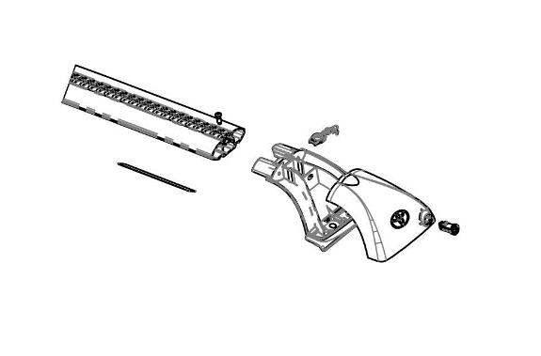
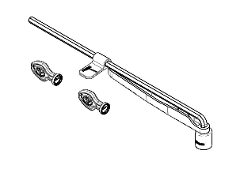
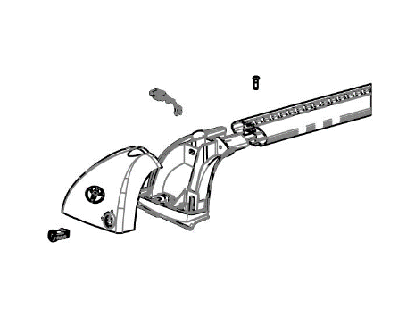
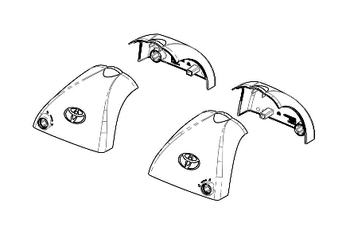
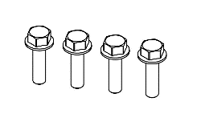
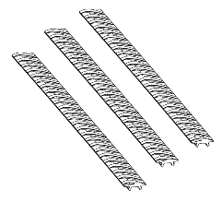
PZQ304808A
PZQ304808D
PZQ304808B
PZQ304808E
PZQ304808C
PZQ304808F

CONTENTS MATRIX
Level | Part Number | Part Description | Qty | Available | Remarks
1 | PZQ3048080 | AERO ROOF RACKS | 1.0 | Yes | Complete Assembly Only
2 | PZQ304808A | Front Bar Assembly | 1.0 | Yes | See Table 2
2 | PZQ304808B | Rear Bar Assembly | 1.0 | Yes | See Table 3
2 | PZQ304808C | Fitting Kit | 1.0 | Yes | See Table 4
2 | PZQ304808D | Tightening and Security Kit | 1.0 | Yes | See Table 5
2 | PZQ304808E | Cover Kit | 1.0 | Yes | See Table 6
2 | PZQ304808F | Rubber Strip Kit | 1.0 | Yes | See Table 7

Table 2 – PZQ304808A – Front Bar Assembly
Description | Qty
AERO STYLE CROSSBAR | 1
LEG – FRONT LEFT | 1
LEG – FRONT RIGHT | 1
COVER – FRONT LEFT | 1
COVER – FRONT RIGHT | 1
SECURE CORE LOCK BARREL | 2
M5X16MM BUTTON HEAD CAP SCREW | 2
VORTEX BUFFER STRIP – 400MM | 2
VORTEX BUFFER STRIP – 200MM | 1
M8 ANTI-ROTATION DEVICE | 2
LOAD/NOTIFICATION LABEL | 1

Table 3 – PZQ304808B – Rear Bar Assembly
Description | Qty
AERO STYLE CROSSBAR | 1
LEG – REAR LEFT | 1
LEG – REAR RIGHT | 1
COVER – REAR LEFT | 1
COVER – REAR RIGHT | 1
SECURE CORE LOCK BARREL | 2
M5X16MM BUTTON HEAD CAP SCREW | 2
VORTEX BUFFER STRIP – 400MM | 2
VORTEX BUFFER STRIP – 200MM | 1
M8 ANTI-ROTATION DEVICE | 2

Table 4 – PZQ304808C – Fitting Kit
Description | Qty
M8x40 HEX HEAD FLANGED BOLT | 4

Table 5 – PZQ304808D – Tightening and Security Kit
Description | Qty
M8 TORQUE INDICATING TOOL | 1
TOYOTA SECURE CORE KEY | 2

Table 6 – PZQ304808E– Cover Kit
Description | Qty
COVER – FRONT LEFT | 1
COVER – FRONT RIGHT | 1
COVER – REAR LEFT | 1
COVER – REAR RIGHT | 1
SECURE CORE LOCK BARREL | 4

Table 7 – PZQ304808F– Rubber Strip Kit
Description | Qty
VORTEX BUFFER STRIP – 400MM | 3

